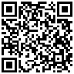
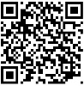


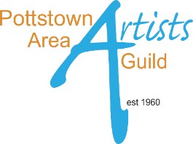
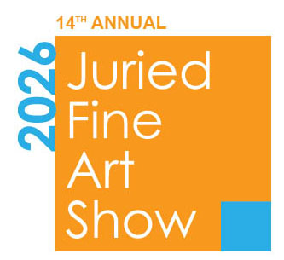
paag.info/juried-show-guest-juror#ai
paag.info/submission-juried-show
Full juror’s bio
https://paag.info/juried-show-guest-juror#juror
Joseph Sweeney is an award winning landscape painter and printmaker based in Ardmore, PA, with degrees from the Phila College of Art and Penn State University. He is a PAFA Fellow, and has served as artist-in-residence at the Undine Barge Club for over forty years.

ENTRIES JUROR Joseph Sweeney

AWARDS JUROR Michele Colonna

Michele Colonna is a curator and cultural strategist exploring the fault line between tradition and technology. As founder of Colonna Contemporary, his curatorial approach is rooted in conviction, favoring artists deeply committed to their practice over trend-driven cycles.

AWARDS $750, $450, $300, and more...

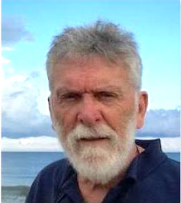
more
ELIGIBLE ARTISTS
ALL 2D and 3D Artists
18 years of age or older

SHOW DATES
Sat, May 30 through Sun June 28

RECEPTION DATE and TIMES
Sat, May 30, 2 to 5
DONOR PREVIEW – 2 to 2:30
PUBLIC – 2:30 to 5

SHOW LOCATION
Schwenkfelder Putera Gallery
105 Seminary St. Pennsburg PA
PARKING is Free at the location.

GALLERY HOURS
• Tue - Sat 10 to 4 PM
• Sat 1 to 4 PM

ACCEPTABLE ARTWORK
• ORIGINALS ONLY in Painting, Drawing, Mixed Media, Sculpture, Collage, Printmaking, Photography, Assemblages.
• 2 ENTRY MAX, not previously shown in the Juried Fine Art Show.
• One entry can be Not for Sale. But not necessary
• Artwork consisting of more than one piece is considered one entry.
• Collaborative art is accepted.

NOT ACCEPTABLE ARTWORK
• NO Generative AI Art.
See website for details

• Schwenkfelder, the host, prohibits:
- nudity in art
- politically charged art

LIABILITY
The GUILD and VENUE are not liable for theft or damage to artwork.

ENTRY FEES - Non-Refundable
SAVE $5 if you apply between
Mar 16 to Apr 3 up to 2 entries
• MEMBERS $25
• NON Members $35
Apr 4 to Apr 17 up to 2 entries.
• MEMBERS $30
• NON Members $40

Want to Join the Pottstown Guild?


ENTRY Online Form
www.paag.info/submission-juried-show If you need help with the form, contact Jeanne: artgal32@gmail.com
midnight, for receipt of entry and payment.

DEADLINE – Apr 17, 2026
CALL FOR ARTISTS

Sun, Jun 28 SHOW CLOSES
4pm

Tue, Jun 30 PICK-UP
2 to 6 PM

Tue, Jun 30 PEOPLE’S CHOICE
Award presented at pick-up. Winner announced on our E-blast, Instagram, Facebook, and Website.

for PDF of drop-off label.
2D ART SPECS
UNFRAMED: 40” MAX
• Gallery wrapped edges with finished edges. No visible staples.

2D ART SPECS
FRAMED: 40” MAX with frame included
• All work must be READY TO HANG.
• WIRED with hooks screwed securely into the wood.
• NO Sawtooth Hangers.
• NO Exposed glass edge clip framing.

3D ART SPECS
• Freestanding or securely attached to a base.
• Pedestals will be provided.
• Have a size limit question? Contact Nicole nicolemcgonigalart@gmail.com

ARTWORK IMAGES
For your entry, we will be asking for
the following images:
• 2D UNFRAMED - supply 1 image
• 2D FRAMED - supply 1 image
• 3D - supply 2 images:
1. Front View
2. Another perspective
(ie. side, back, detail)

IMAGES FILE SPECS
• FILE NAME
LASTname_FIRSTname_TITLE (ie. Smith_Joe_Eagerly Awaiting)
• 300 dpi we will be using them for printing
• 1200 pixels longest side

ARTIST TALKS
You’ll be asked whether you want to participate. Three artists from different media will each speak for 3 minutes, with strict time limits.

ARTIST STATEMENT
A 30 word narrative on each piece of art describing your inspiration, techniques, etc.

C A L E N D A R
Mon, Mar 16 Applications open

Fri, April 10 DEADLINE midnight for ENTRY & RECEIPT of payment.
NO SUBSTITUTIONS or CHANGES will be accepted after the deadline.

Fri, May 1 ACCEPTANCE NOTICE
Acceptance into this show allows Pottstown Area Artists Guild to use your artwork images for promotion and education.
The accepted entry is what’s required to be in the show. Please set it aside. NO SUBSTITUTIONS.

Tue, May 26 DROP-OFF
2 to 6 pm

Questions? contact
Show Chair Nicole McGonigal
nicolemcgonigalart@gmail.com
ARTIST WORKING IMAGE
Folks love to see an artist at work.
AND, your studio DOES NOT HAVE TO BE CLEAN!

BRING A SWEET to share for the reception. There will be a sign-up at drop-off

DROP-OFF
• At show location.
• In person only. No shipments.
• If you are sending someone in your place contact Nicole ASAP
nicolemcgonigalart@gmail.com
and provide their name.
• Each piece of art must have a drop-off label, attached on back.

Reception & Awards Ceremony
SATURDAY
May 30, 2 to 2:30pm
Donor Preview

SATURDAY
Sat, May 30, 2:30 to 5pm
Open to the Public

original art, art installation by sculptor Val Bertoia, artist talks, live music, cash raffle

For promo on our Social Media, Website, E-blasts.
PICK-UP
• At show location.
• No Shipping back to artist.
• $10/day fee for any art not collected.
• If you are sending someone in your place contact Nicole ASAP nicolemcgonigalart@gmail.com
and provide their name.

SALES
• Commission 30% 15% Schwenkfelder Center
15% Pottstown Area Artists Guild

• Artwork remains up until end of show unless approved by the Show Chair.

• Artist is responsible for delivery to buyer.

• The guild will collect 6% PA Sales Tax and remit to the PA Dept of Revenue.

• A W-9 is required for sales totaling $600 or more.

• Artist will receive a check shortly after the show ends.

